Task 1: Bug Report

ID: 1
Title: Close button overlaps text in the registration window
Environment: Chrome 141, Windows 11
Preconditions: A new user is on the main page
Steps to reproduce:
- Open the registration window (click the Register button)
Expected result:
The text and the close button are placed in separate sections with sufficient spacing between them
Actual result:
The close button overlaps the text “Let’s discover this world together”
Attachments:

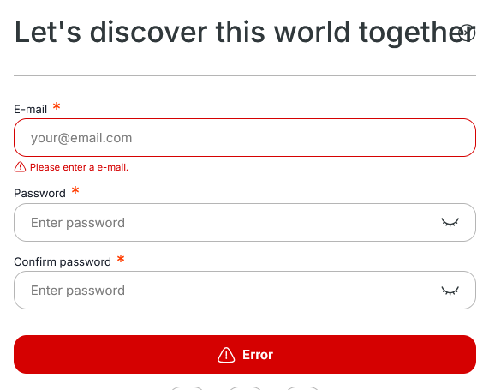

ID: 2
Title: No option to generate a strong password in the first password input field during registration
Environment: Chrome 141, Windows 11
Preconditions: A new user is on the main page
Steps to reproduce:
- Open the registration window (click the Register button)
- Click on the first password input field
Expected result:
An option to generate a strong password is displayed
Actual result:
No option to generate a strong password is displayed
Attachments:
Second screenshot showing the second password input field with better functionality

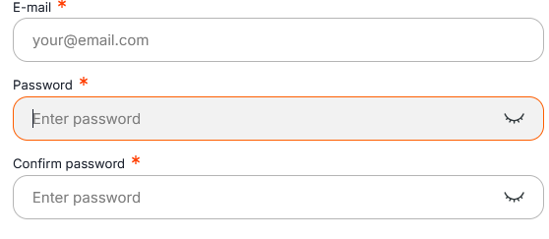
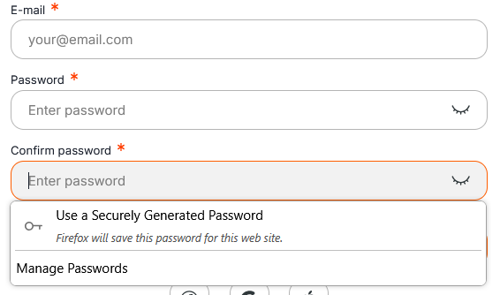

ID: 3
Title: Submit button does not respond when submitting tutorial feedback
Environment: Chrome 141, Windows 11
Preconditions: A new user has registered and completed the tutorial
Steps to reproduce:
- Select any rating
- Click the Submit button
Expected result:
The feedback window closes and the user is redirected to the main page
Actual result:
The feedback window remains open and the rating is not submitted
Attachments:

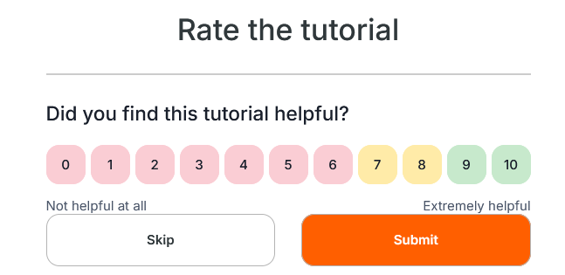
ID: 4
Title: “Go to homepage” button does not work in the “My travels” window
Environment: Chrome 141, Windows 11
Preconditions: The user is on the main page
Steps to reproduce:
- Click the account icon
- Select My travels from the dropdown menu
- Click Go to homepage
Expected result:
The My travels window is closed and the user is navigated to the main page
Actual result:
The My travels window remains open
Attachments:

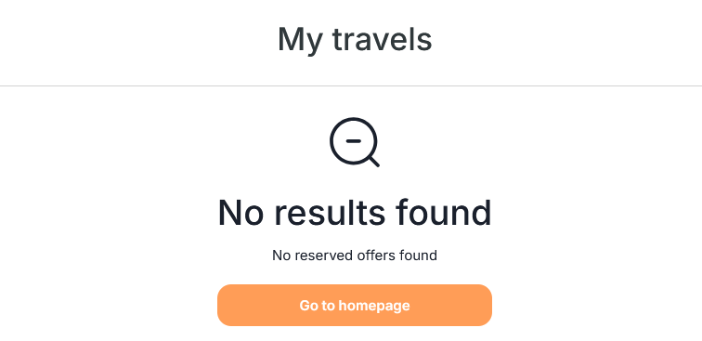

ID: 5
Title: Displayed number of liked rooms in the header does not match the actual count
Environment: Chrome 141, Windows 11
Preconditions: The user has liked several rooms
Steps to reproduce:
- Navigate to the comparison table of liked rooms
- Remove one, several, or all rooms from the table
- Refresh the page
Expected result:
The number of liked rooms displayed in the header updates to match the actual number of rooms
Actual result:
An incorrect number is displayed in the header
Attachments:

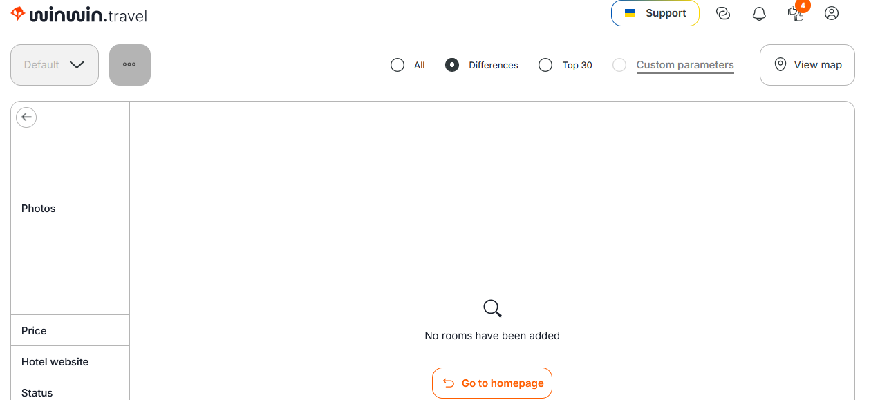

ID: 6
Title: User can register using an invalid email address (gmail.co)
Environment: Chrome 141, Windows 11
Preconditions: A new user is on the registration page
Steps to reproduce:
- Enter an invalid email address (e.g., example@gmail.co or example@gmail.con)
- Fill in all other required fields
- Submit the registration form
Expected result:
Registration is rejected and an error message “Please enter a valid email address” is displayed
Actual result:
A non-existent email address is successfully registered in the system
Attachments:
